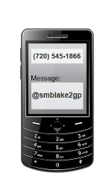 **(REMIND 101) Please follow these steps to receive your messages:**

Send a text message to

GEOMETRY

PARENT

With the message

You will receive a txt

message from

Mrs Blakely asking for

your name to complete

the setup