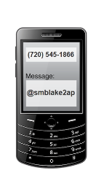
(REMIND 101) Please follow these steps to receive your messages:

Send a text message to
ALGEBRA 1
PARENT

With the message

You will receive a txt
message from
Mrs Blakely asking for
your name to complete
the setup

